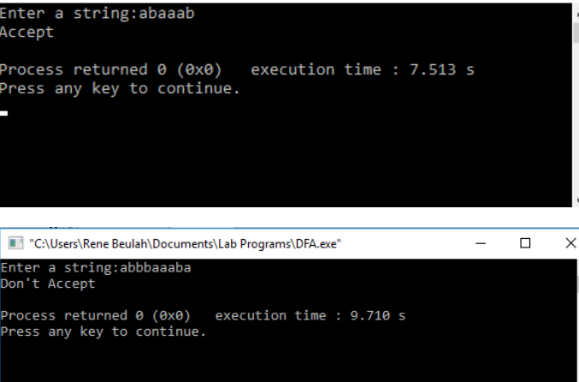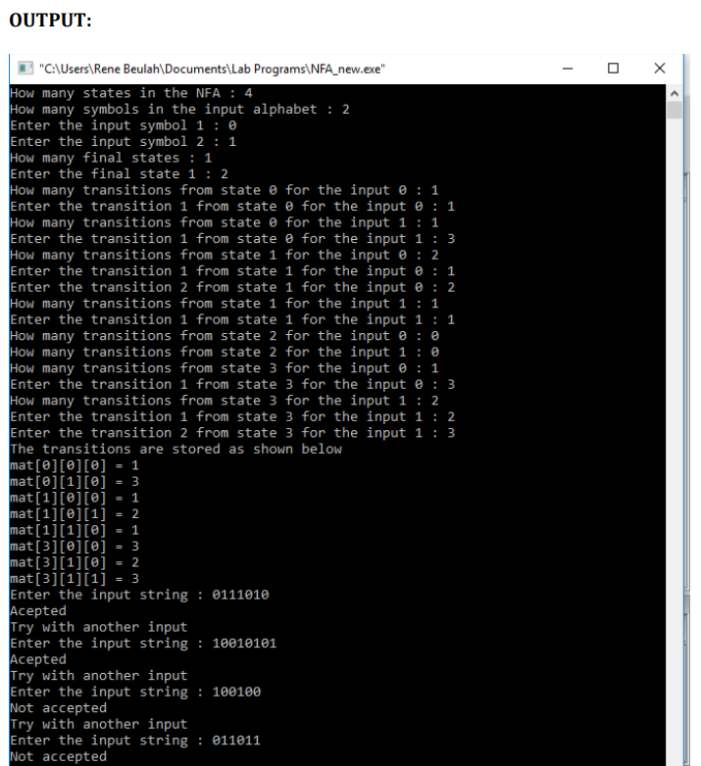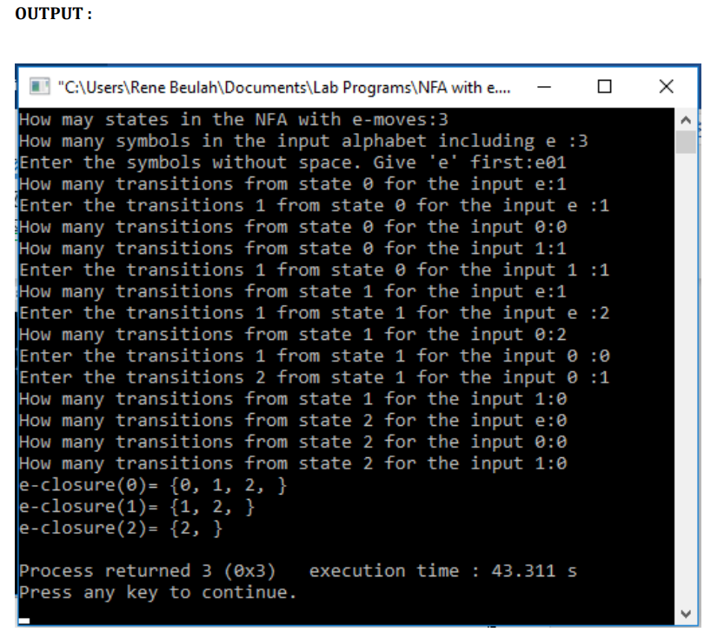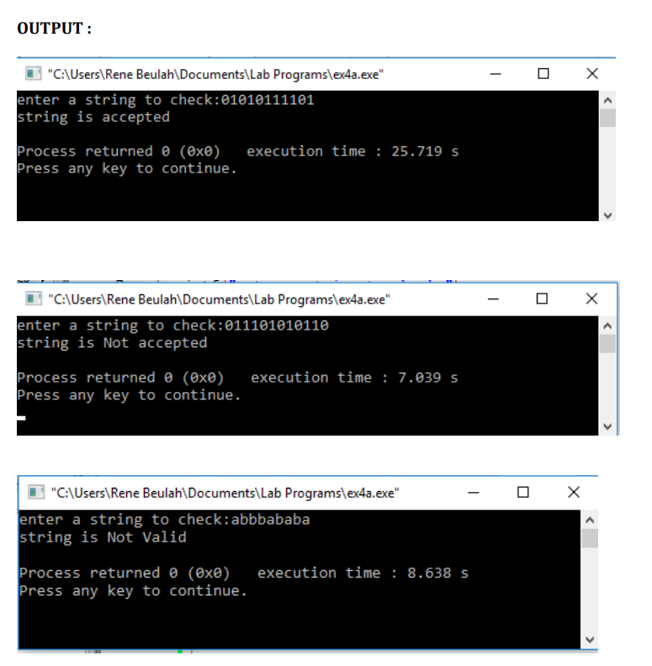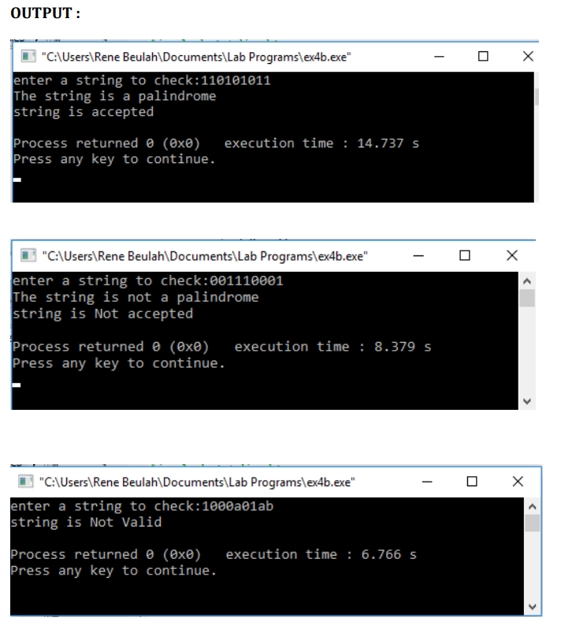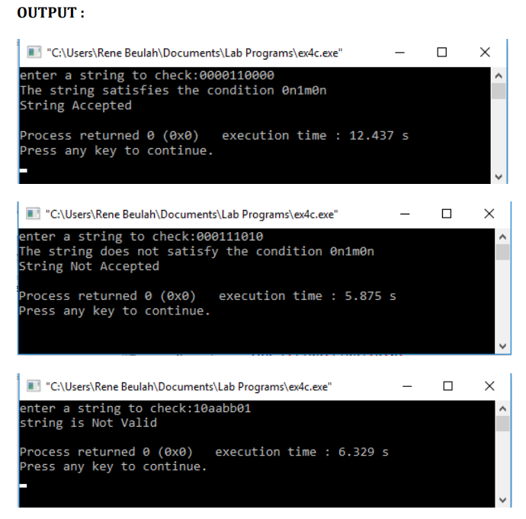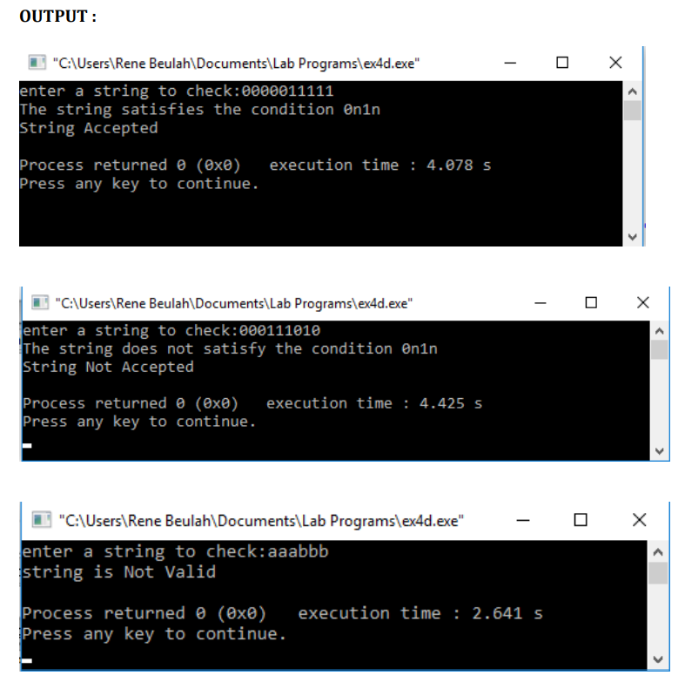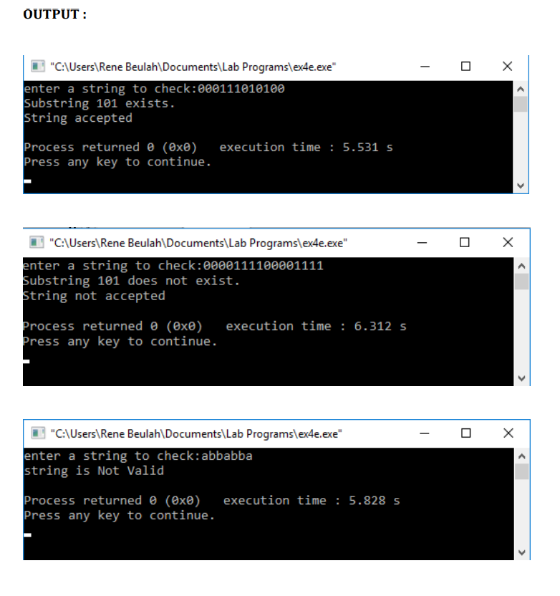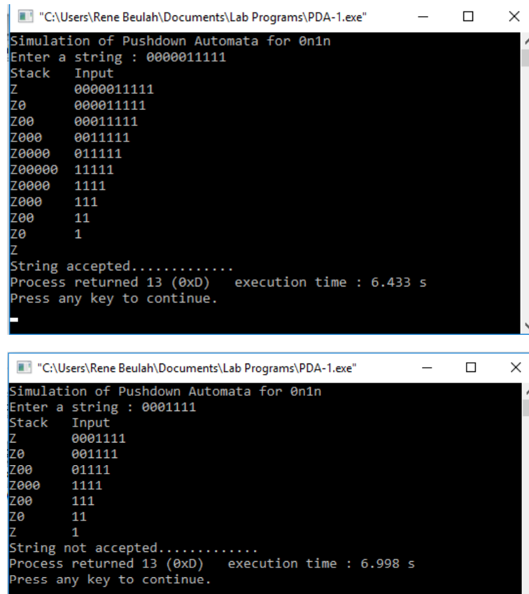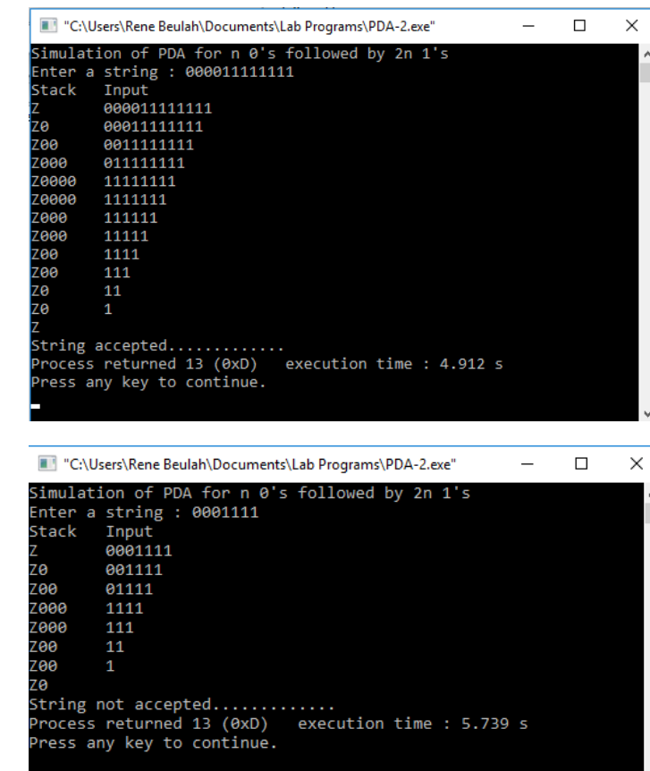

Output for deterministic finiteautomata

Output for nondeterministic finite automata

C output for e closure for all the states in non DFA

Check whether given string belongs to the language defined by CFG ex 1

Check whether given string belongs to the language defined by CFG ex 2

Check whether given string belongs to the language defined by CFG ex 3

Check whether given string belongs to the language defined by CFG ex 4

Check whether given string belongs to the language defined by CFG ex 5

C output to simulate PDA for grammar 0n1n

C output to simulate PDA for lang a^nb^2n

C output to simulate a TM for a given language

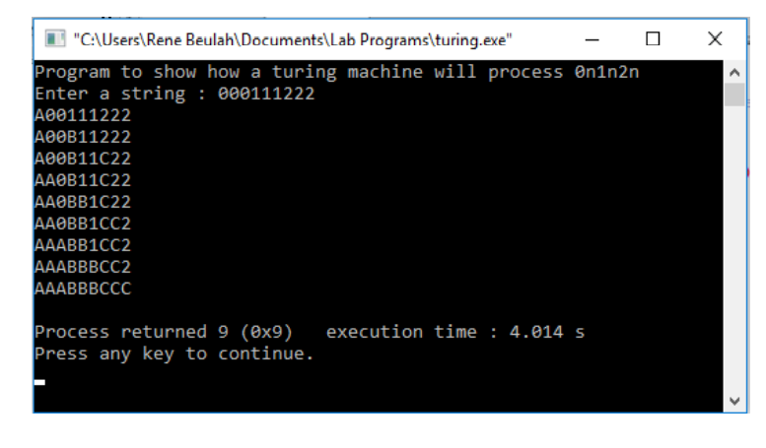

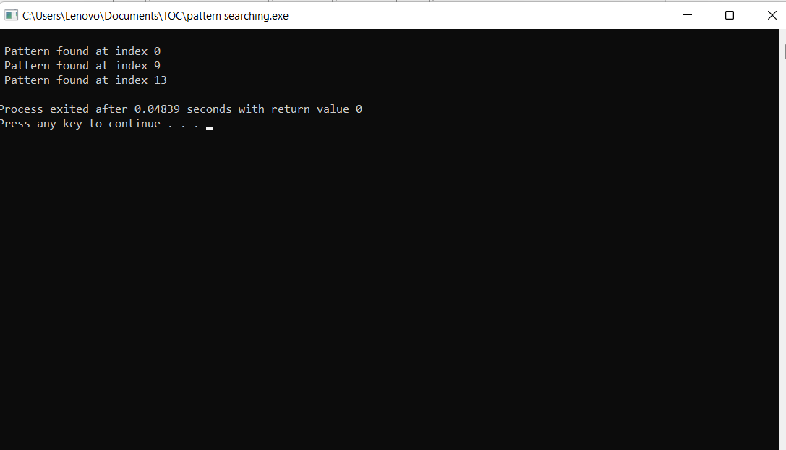C output to print a pattern